ECOMMERCE REPORT

**The dataset being referred to :**

* Promotions
* Sale Data Ecommerce

**Price Variation**

* + **Price by category**

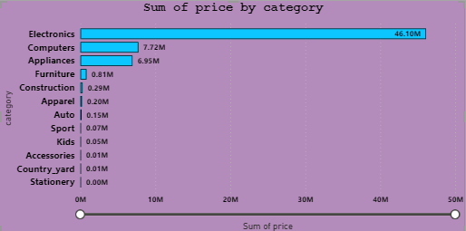

At 46,099,574.52, Electronics had the highest sum of prices, which was 3,532,136.71% higher than Stationery, the category with the lowest sum of prices at 1,305.11. Electronics accounted for 73.91% of the total sum of prices across all categories. The sum of prices ranged from 1,305.11 to 46,099,574.52 across all 12 categories.

* + **Price by Event hour**

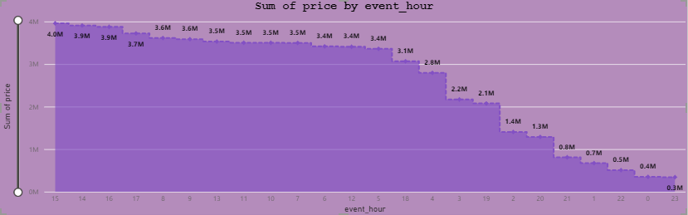

At 3,959,381.34, event_hour 15 had the highest sum of price, which was 1,054.52% higher than event_hour 23, the one with the lowest sum of price at 342,945.37. Event_hour 15 accounted for 6.35% of the total sum of prices across all event_hours. The sum of prices ranged from 342,945.37 to 3,959,381.34 across all 24 event_hours.

Since traffic is higher during the day and lower at night, we could consider offering discounts during nighttime hours. This strategy may help increase traffic during those hours as well.

Traffic

* Traffic by day of week

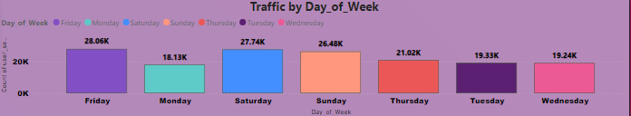

At 28,062, Friday recorded the highest count of user sessions, which was 54.77% higher than Monday's count of 18,131, the lowest count for the week. As Friday accounted for 17.54% of the total count of user sessions, it's evident that it's a significant day for traffic. However, considering Monday's lower traffic, offering discounts on that day could help boost activity. Across all 7 days of the week, the count of user sessions ranged from 18,131 to 28,062..﻿

* Traffic by Channel

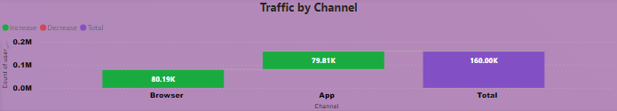

The traffic is nearly equal in both channels. Through browsers, it's 80.19k, and through the app, it's around 79.81k, with only a slight difference that can be ignored.

* Traffic by Event Hour

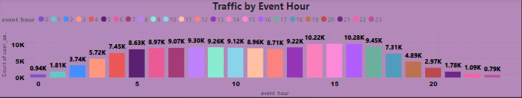

Since traffic is higher during the day and lower at night, we could consider offering discounts during nighttime hours. This strategy may help increase traffic during those hours as well.

Things to focus more on

With an overall traffic of 160k, it's important to note that the number of people who added items to the cart is approximately 19.4k, while the viewed traffic stands at 125.93k, and the purchase traffic is about 14.65k. Given this data, it suggests that there's a significant gap between viewed traffic and purchase traffic, indicating an opportunity to focus more on converting viewed traffic into actual purchases. Additionally, efforts should be made to convince cart traffic to proceed with purchasing the items in their carts. By optimizing strategies to convert both viewed and cart traffic into purchases, we can effectively increase sales.

**Data Matrix**

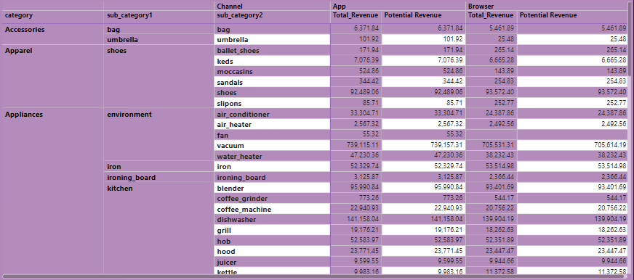

* Top 3 Revenue Generating Categories:  
   - Electronics: This category is the top revenue generator with 46,080,461.73, indicating a strong consumer demand for electronic products. It suggests a significant market share and potential for growth in this sector.  
   - Computers: With a revenue contribution of 7,722,913.19, computers emerge as another important revenue driver. This highlights the significance of computer-related products in the market and underscores opportunities for further market penetration and product innovation.  
   - Appliances: Generating 6,945,748.22 in revenue, appliances demonstrate steady demand in households. This suggests a stable market segment that could benefit from targeted marketing efforts and product diversification.  
    
  2. Lowest 3 Revenue Generating Categories:  
   - Stationery: With the lowest revenue of 1,305.11, stationery items indicate minimal sales. This may suggest either low demand or a niche market with limited sales potential, requiring further analysis to determine appropriate strategies.  
   - Country Yard: Contributing 7,283.22 in revenue, country yard products exhibit relatively lower demand compared to other categories. Understanding consumer preferences and market dynamics in this segment could help in devising targeted marketing strategies.  
   - Accessories: Generating 11,961.13 in revenue, accessories fall into a moderate demand category. While not as low as stationery, this revenue figure suggests room for improvement in capturing a larger market share through targeted marketing and product enhancements.  
    
  3. Insights and Recommendations:  
   - Market Focus : Focus on expanding the product range and market presence in high revenue-generating categories like Electronics and Computers to capitalize on strong consumer demand.  
   - Diversification Strategies : Consider diversification or targeted marketing campaigns to enhance sales in lower revenue categories such as Stationery and Country Yard.  
   - Optimization : Continuously monitor and optimize product offerings, pricing strategies, and marketing efforts to maximize revenue across all categories.  
   - Customer Insights : Gather customer feedback and conduct market research to better understand preferences and trends driving sales in each category.
* **Search Behavior**
* **Brand Search by category**

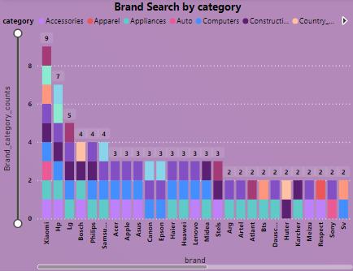

Highest Search Behavior Brands:  
Xiaomi (9): Xiaomi tops the list with the highest search behavior, indicating strong consumer interest and brand recognition within the category.  
HP (7): HP follows closely with significant search behavior, suggesting a strong presence and consumer engagement in the category.  
LG (5): LG ranks third in search behavior, demonstrating moderate interest and engagement among consumers.  
  
Lowest Search Behavior Brands:  
Several brands, including Yamaha, Vivo, Thomas, Starline, Redmond, Pulser, Oppo, OnePlus, Nokia, MSI, Kivi, Janome, Indesit, Hansa, Force, Casio, BRW, Braun, Beku, and Aristone, each have a search behavior of 1.  
These brands exhibit minimal search behavior, indicating relatively lower consumer interest or brand recognition within the category.  
  
Insights:  
Brand Dominance: Xiaomi and HP emerge as dominant brands with the highest search behavior, suggesting strong brand awareness and consumer preference.  
Opportunity for Growth: Lower-ranked brands with minimal search behavior represent opportunities for improvement in brand visibility, marketing strategies, and product offerings to enhance consumer engagement.  
Consumer Preferences: Analyzing search behavior can provide insights into consumer preferences, trends, and potential areas for brand expansion or diversification.  
Competitive Analysis: Understanding the search behavior of different brands allows for competitive analysis and benchmarking against industry peers to identify strengths, weaknesses, and areas for differentiation.  
  
Recommendations:  
Enhanced Marketing Efforts: Invest in targeted marketing campaigns to increase brand visibility and consumer engagement for lower-ranked brands.  
Product Innovation: Focus on product innovation and differentiation to attract consumer interest and stand out in a competitive market.  
Strategic Partnerships: Explore partnerships or collaborations to leverage the strengths of dominant brands and expand market reach for others.  
Data-driven Decision Making: Utilize insights from brand search behavior data to inform strategic decision-making, optimize marketing budgets, and prioritize resource allocation.

* **Category Search by Brand**

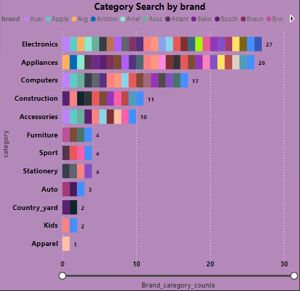

High Search Behavior Categories:  
 Electronics: This category has the highest search behavior with a score of 27, indicating a strong interest and engagement from users in searching for electronic brands. This suggests a high demand for electronic products and potential opportunities for targeted marketing and promotions.  
Appliances: Following closely behind electronics, appliances have a search behavior score of 26, indicating significant user interest in searching for appliance brands. This highlights the importance of household appliances and suggests a potential market for appliance-related products and services.

Low Search Behavior Categories:  
Apparel: With a search behavior score of 1, apparel brands exhibit the lowest search behavior among the categories listed. This may suggest lower user engagement or interest in searching for apparel brands, indicating potential challenges in capturing audience attention or competition from other categories.  
Kids: Kids-related brands have a search behavior score of 2, indicating minimal user engagement in searching for kids' brands. Understanding the reasons behind this low search behavior could help in identifying opportunities for improving brand visibility and attracting more users.  
Country Yard and Auto: Both Country Yard and Auto categories have a search behavior score of 2 and 3, respectively. This suggests relatively low user interest in searching for brands within these categories, indicating potential areas for improvement in marketing strategies or brand positioning to increase user engagement and visibility.

Insights and Recommendations:  
Focus on High Search Categories: Allocate resources and marketing efforts towards high search behavior categories like Electronics and Appliances to capitalize on user interest and engagement.  
Improve Visibility for Low Search Categories: Explore strategies to increase brand visibility and user engagement in low search behavior categories such as Apparel, Kids, Country Yard, and Auto. This could include targeted marketing campaigns, partnerships, or product diversification to attract more users.  
Monitor and Analyze Trends: Continuously monitor search behavior trends and user preferences to adapt marketing strategies and enhance brand presence in relevant categories.  
Enhance User Experience: Improve the user experience on the platform to facilitate easier and more intuitive brand searches, which could help increase user engagement across all categories.

**Variations After Discount**

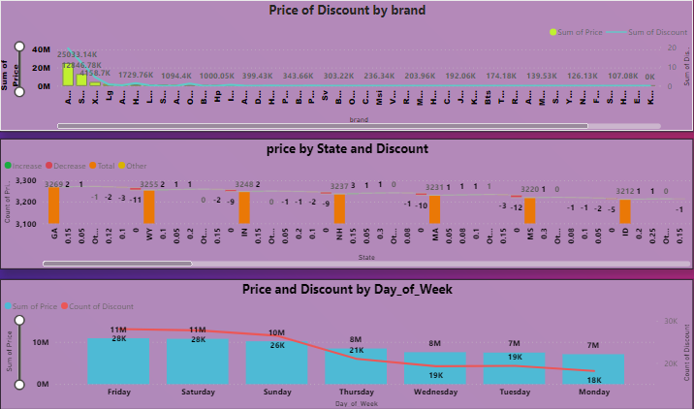

At 25,033,135.68, Apple had the highest sum of price and was 44,935.08% higher than Arg, which had the lowest sum of price at 55,585.86.

The sum of price and total sum of discount are positively correlated with each other.

Apple accounted for 40.14% of the sum of price.

The sum of price and sum of discount diverged the most when the brand was Apple, with the sum of price being 25,033,116.33 higher than the sum of discount.

Across all 7 days of the week, the sum of price ranged from 7,095,025.63 to 10,871,756.47, and the count of discount ranged from 18,131 to 28,062.

Highest Price Discount State (GA):  
Count of Prices: 3,269

Insights:  
Georgia (GA) exhibits the highest count of price discounts among all states, indicating a significant number of discounted products or services being offered in this region.  
The high number of price discounts in Georgia suggests a competitive market environment or promotional strategies aimed at attracting consumers through discounted pricing.  
Analyzing the types of products or services with discounts in Georgia can provide valuable insights into consumer preferences and market trends in the region.  
Businesses operating in Georgia may benefit from leveraging discounts as a marketing tool to attract customers and drive sales.  
Lowest Price Discount States (HI and NM):  
  
Hawaii (HI):  
Count of Prices: 3,001  
New Mexico (NM):  
Count of Prices: 3,017

Insights:  
Hawaii (HI) and New Mexico (NM) have the lowest count of price discounts among all states, suggesting a comparatively lower prevalence of discounted products or services in these regions.  
The lower number of price discounts in Hawaii and New Mexico may indicate a less competitive market environment or different consumer behavior compared to states with higher discount counts.  
Businesses operating in these states may need to explore alternative marketing strategies beyond price discounts to attract and retain customers.  
Analyzing the factors contributing to the lower prevalence of price discounts in Hawaii and New Mexico can provide insights into consumer preferences, economic conditions, and market dynamics in these regions.

Overall Insights:  
Understanding price discount trends by state can help businesses tailor their marketing and pricing strategies to specific regional preferences and market conditions.  
Monitoring price discount data over time can reveal seasonal trends, economic fluctuations, and shifts in consumer behavior, enabling businesses to adapt their strategies accordingly.  
Analyzing the effectiveness of price discounts in driving sales and customer engagement can inform future promotional activities and resource allocation decisions.